<https://towardsdatascience.com/predicting-the-success-of-kickstarter-campaigns-3f4a976419b9>

1. look at average goal-amount of
   1. failed
   2. succes

→ same for all somewhat important features

1. 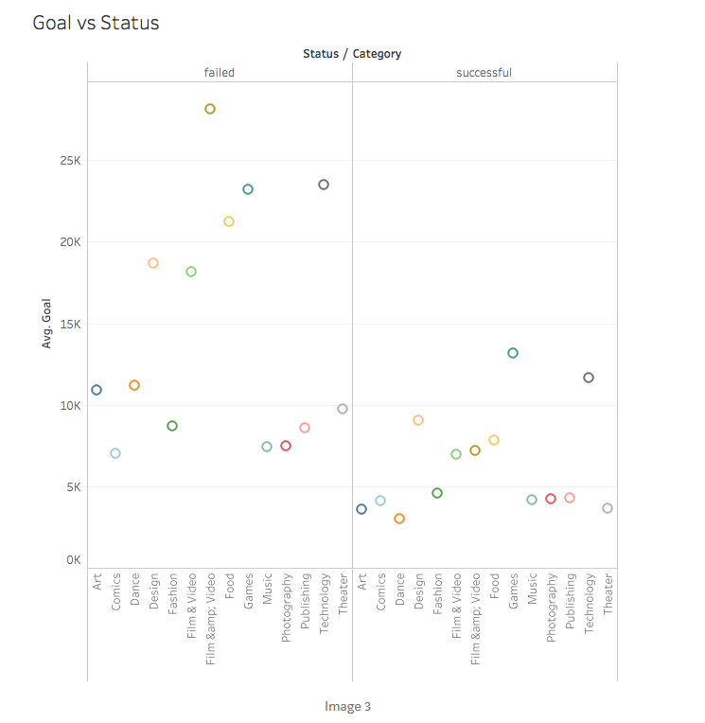
2. plot all categories not with success and fails, but with only one bar → Success rate, which detects actual relation between success and fail
3. Limit country to US? → anpassen auf business case

<https://towardsdatascience.com/using-machine-learning-to-predict-kickstarter-success-e371ab56a743>

1. Whole EDA part and conclusion part → **gute takeaways**
2. → Extract hours? maybe make morning, noon and evening out of it?

<https://www.kaggle.com/gagejustins/kickstarter-analysis-and-prediction>

1. predict backers / pledged amount with regression

<https://blog.goodaudience.com/kickstarter-projects-prediction-of-state-steps-for-a-beginner-analysis-f4630a50b7fe>

1. Competitor feature?

<https://thehustle.co/crowdfunding-success-rate>

1. how hard to failed project fail?